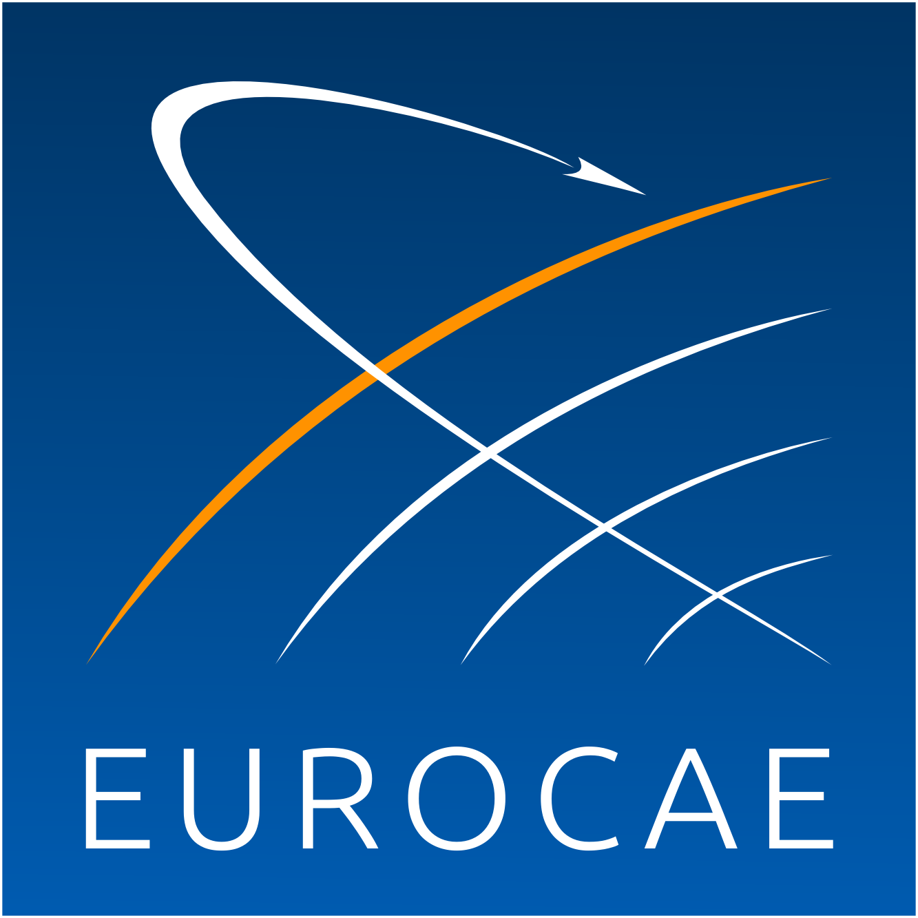

The European Organisation for Civil Aviation Equipment

L’Organisation Européenne pour l’Equipement de l’Aviation Civile

EUROCAE WG-106
“Electronic Flight Bag (EFB)”

Call for Participation*

*EUROCAE requires membership to follow Working Group activities.
For information please consult: https://www.eurocae.net/organisation/join/

Firm or Organisation:

- If this activity is initiated, will your firm or organisation participate? YES NO

Designated representative(s):

Name:
Address:

Tel.: Fax.:
Email:

Will attend as: - Active Member YES NO
- Observer YES NO

NOTE: The date for the kick off meeting will be fixed shortly and the calling notice will be issued in due course to the nominated participants of this WG.

Possible comments:

Name:
Date:
Signature:

To be returned to EUROCAE General Secretariat by 09 December 2016

by e-mail to eurocae@eurocae.net

